# CS 255 System Design Document

## UML Diagrams

### UML Use Case Diagram

### UML Activity Diagrams

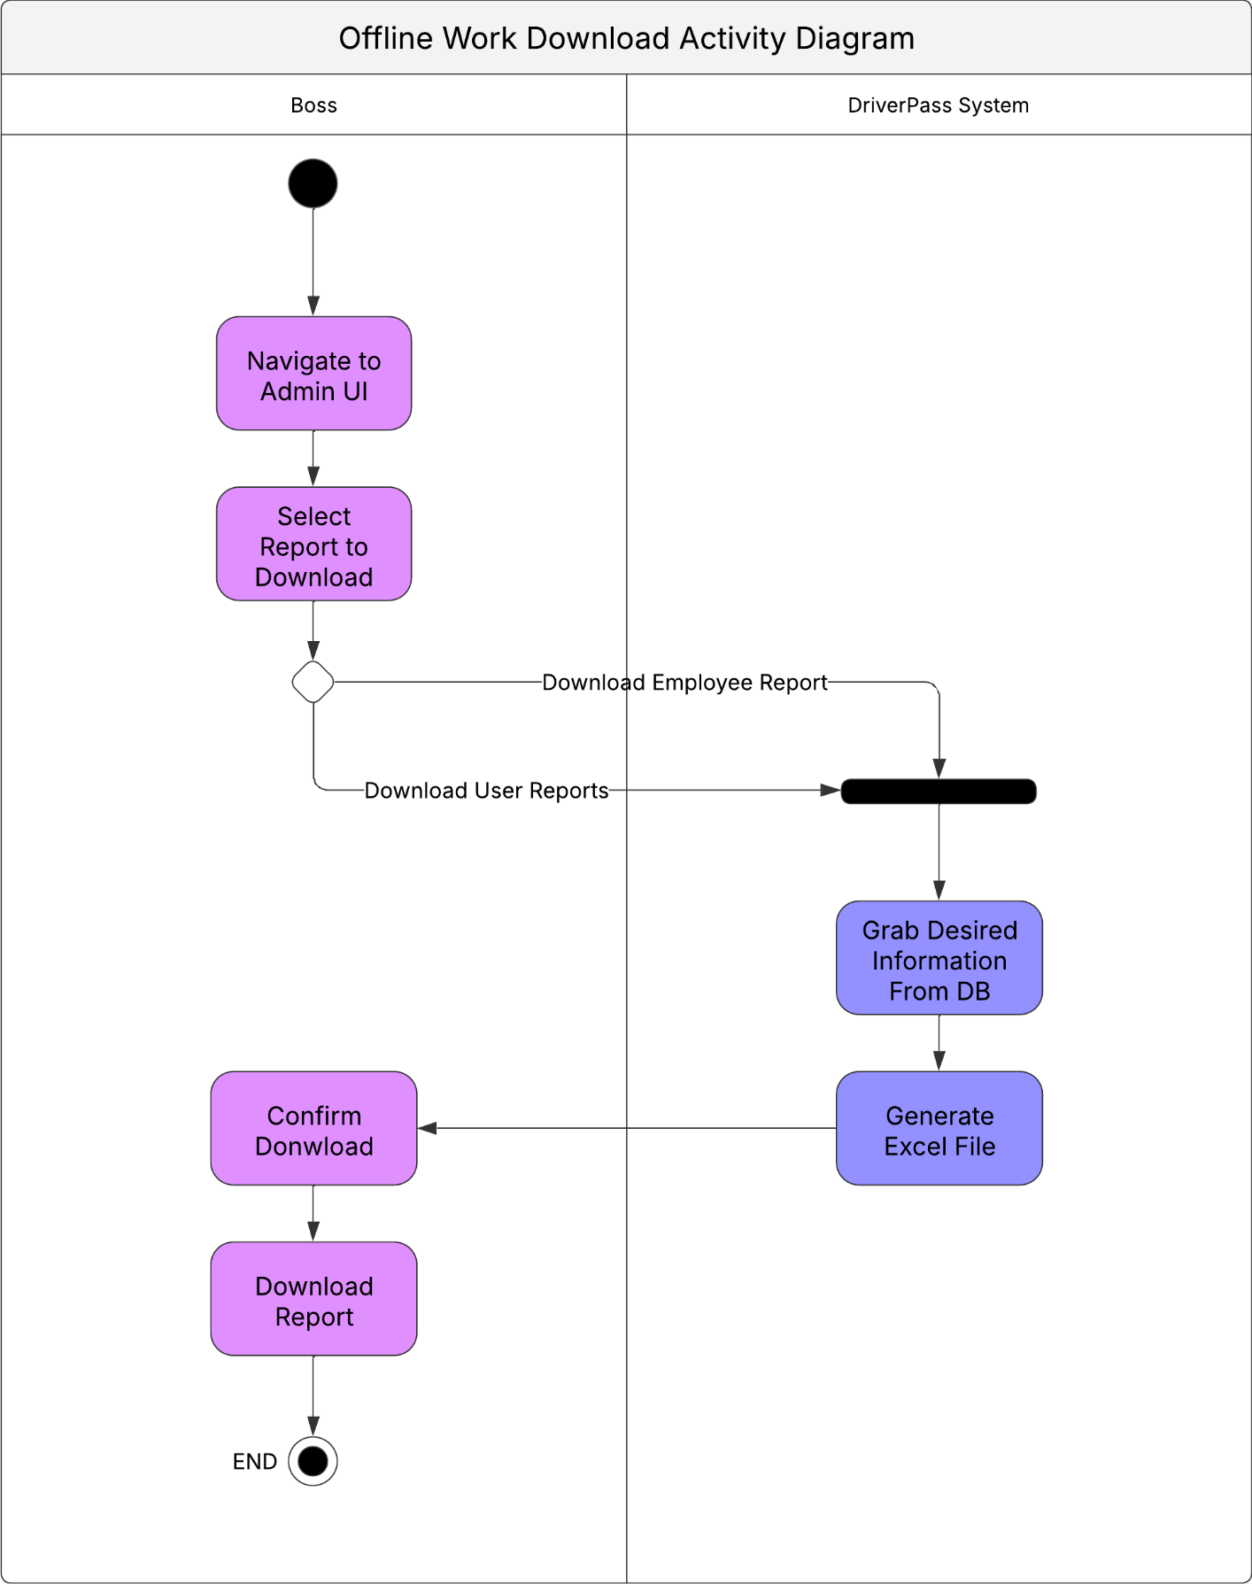

### UML Sequence Diagram

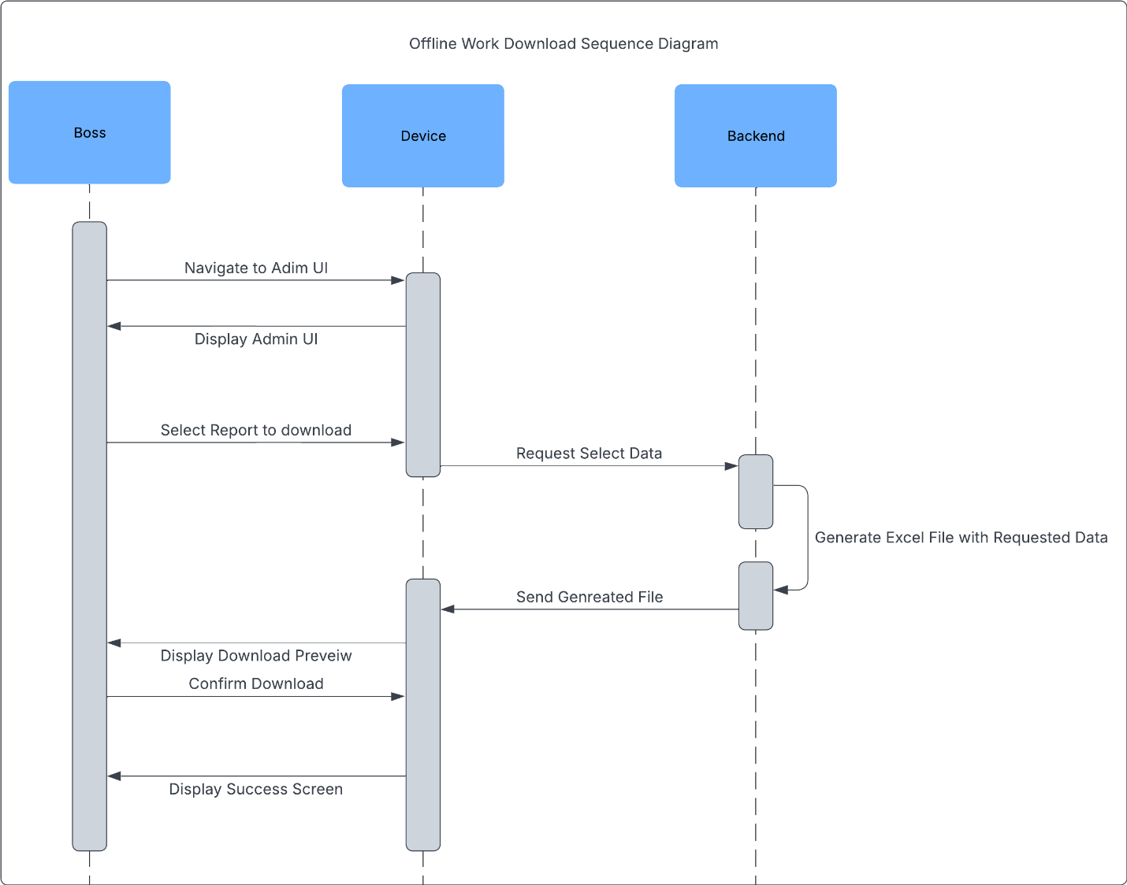

### UML Class Diagram

## Technical Requirements

*The system is required to run on all available platforms including Desktop, Mobile and Web. The system should be optimized to run on lower end machines. They system should be maintained and updated regularly to address any potential bugs or leaks in the system. Additionally, the system should maintain online status so we should make use of Cloud Hosting Providers in order to achieve this. All systems should run on the cloud Including the API and Database. An information pipeline between the DMV and DriverPass is required in order to keep driving rules, regulations, and tests up to date with state code. Specific Recommendations listed below:*

* *Amazon Web Services*
* *Amazon Cloud SQL database*
* *Amazon Cloud Container to run API*